Back to home programmer
Introduction
Shree Indra Danush Primary School was established in 2003 A.D under the trust of Shree Tsering Dolma. Around 80 students are getting free education. Comparing to the urban school it’s totally different. There are six teachers who is running this school. They do what they like. The system is totally different. Teachers are found outside the class rather than inside. The children are compile to bring fire wood, foods and sometimes they are force to cook the food to the teacher. The rules and regulation are not properly mentioned. But one thing I like most the every Friday all the children clean all the class by putting water and sweep with sack.
While assembly time they do pray and sing national anthem. They do in a hurry way. The classes are not enough some class is conducted outside the room. The school structure is so nice and so amazing. The school is just below the stupa and down side there is Small River which has increase the beauty of the school. There is a toilet for the teacher in a school premise and for students outside the school premise. They organize parent’s day and celebrate Lhosar. The school provides education up to grade five and after completing they are brought to Kathmandu for the further study.
Back ground
Objective
To open school: Every organization has their own aim and goal. The school aims to provide many facilities to the children as much as they demand for the quality education, bright future and self dependence. Mainly it tries best to provide quality education to all the children of Nepal. The main reason behind the establishment of the school are given below:
- To provide quality education to the village children.
- To make the children conscious about the modern world and the way how its run.
- To make the bright future of children from the remotest part.
- To socialized the children with the modern amenities and to make them to stand on their own feet.
- To motivate the children on their dreams, destination, make them self dependent and self reliance.

Schedule of teaching in Shree Indra Danush primary School.

S.N | Day | Date | Duration | Subject
1 | Sunday | 2015-05-03 | 45 minutes (only 1 period) | Indirection
2 | Monday | 2015-05-04 | 45 minutes (only 1 period) | English
3 | Tuesday | 2015-05-05 | 90minutes (only 2 period) | Social and moral science
4 | Wednesday | 2015-05-06 | 90minutes (only 2 period) | English and social
5 | Thursday | 2015-05-07 | 45 minutes (only 1 period) | English
6 | Friday | 2015-05-08 | 90minutes (only 2 period) | English and math
7 | Sunday | 2015-05-10 | 45 minutes (only 1 period) | English
8 | Monday | 2015-05-11 | 45 minutes (only 1 period) | Social
9 | Tuesday | 2015-05-12 | 90minutes (only 2 period) | Social and moral science
10 | Wednesday | 2015-05-13 | 45 minutes (only 1 period) | Social
11 | Thursday | 2015-05-14 | 90minutes (only 2 period) | Social and moral science
12 | Friday | 2015-05-15 | Full time(9:55-4:00pm) | English, Math, Social, and moral science
13 | Sunday | 2015-05-17 | Full time(9:55-4:00pm) | English, Math, Social, and moral science
14 | Monday | 2015-05-18 | Full time(9:55-4:00pm) | English, Math, Social, and moral science
15 | Tuesday | 2015-05-19 | Full time(9:55-4:00pm) | English, Math, Social, and moral science
16 | Wednesday | 2015-05-20 | Full time(9:55-4:00pm) | English, Math, Social, and moral science
17 | Thursday | 2015-05-21 | Full time(9:55-4:00pm) | English, Math, Social, and moral science
18 | Friday | 2015-05-22 | Full time(9:55-4:00pm) | English, Math, Social, and moral science
19 | Saturday | 2015-05-23 | Half day | English, Math, Social, and moral science
20 | Sunday | 2015-05-24 | Full time(9:55-4:00pm) | Organized river cleaning programmed
21 | Monday | 2015-05-25 | Full time(9:55-4:00pm) | English, Math, Social, and moral science
22 | Tuesday | 2015-05-26 | Full time(9:55-4:00pm) | English, Math, Social, and moral science
23 | Wednesday | 2015-05-27 | Full time(9:55-4:00pm) | English, Math, Social, and moral science
24 | Thursday | 2015-05-28 | Full time(9:55-4:00pm) | English, Math, Social, and moral science

Details
I went to talk with the teacher of Shree Indra Danush Primary School for the promotion to take classes as a volunteer. There was a problem of teachers and they gave me promotion to teach there as much as I can. I felt very happy that I could do something for my villagers.
It was my first time I felt little bit nervous. Everyone was staring and laughing at me. I was trying to ignore all these things and go forwards. I didn’t teach them. We had interacted. I introduced myself and let them tell their name, age and ambition. On second day I looked the English book. There was lesson which teaches or increase the conversation capacity of children. Students need to make conservation by looking the picture. I did take their class only for 45 minutes. I couldn’t take the whole day because I need to help my brothers in the field.
Till May 13th I couldn’t take all the classes because I have to help my brother to cultivate the grains and maize. Someday I taught them only English and someday I taught those English and math, and some time moral science and social. During these days I was provided all the foods by school teachers union.
From 14th of May I started to take full hours classes. There was six classes altogether in Shree Indra Danush Primary school. Nyawang sir was so amazing. He was most popular teacher among all. He was teaching Tibetan subject.
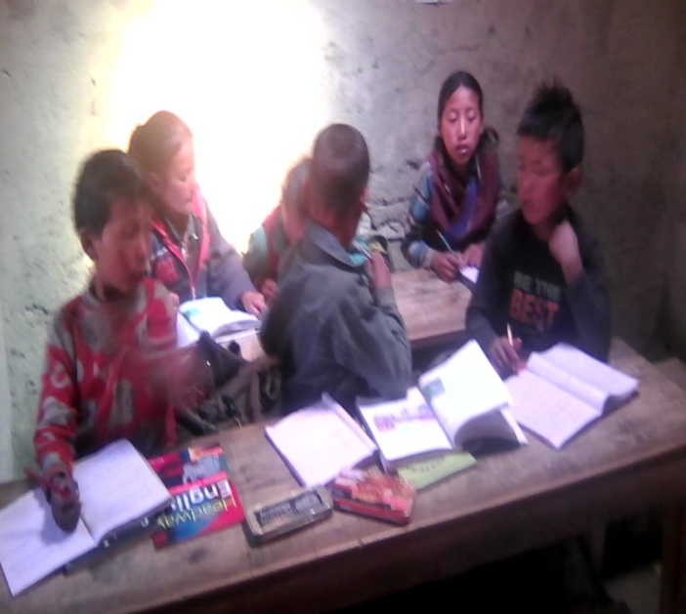
From 14th May I taught English, math,
Social studies and moral Science. It was
mine great experience .
I went there as a volunteer teacher but I
Learn from their side as well. They
taught me my own language. Some of the
Students can easily capture me and
Some can’t due to my language. For that
Need to tell them more than five times and
to write all the answers that are
asked in exercises. If any homework I gave
then they get angry they wish to do all the
exercises in class room by myself. I used to
solve their problems. Grade three students
Invite me for dinner on their home.

During my teaching period I have nothing any problems. Everything was fine there. Very close to the school premises there is Small River. It was so dirty. All the garbage was thrown there. I plane to clean that. I talk this matter with head teacher and he told me that “if you want to clean then you may do on Saturday. I will call all the students for you”. I said thank you to the teacher.

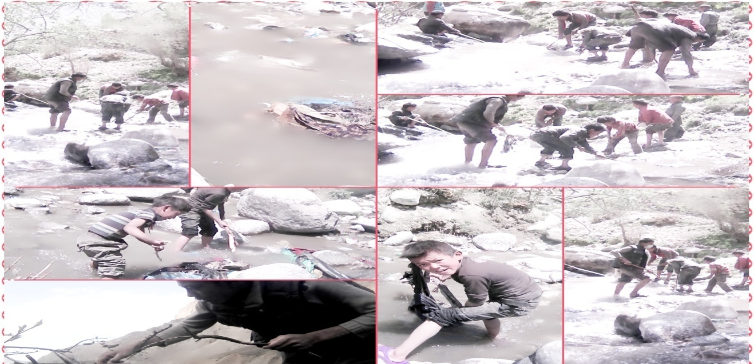
Figure 1: students are cleaning river called Pola
Differences of village school and town school are shown below:

S.N | Town School (Kathmandu) | Village school (my village)
1 | All the rules and regulation are properly mentioned. | No proper rules and regulation are mentioned.
2 | All the teachers are well qualified. | Teachers are not so qualified.
3 | Technique teaching system is implementing. | No any technique teaching system.
4 | All the classes were well managed. | Classes were not well managed.
5 | Teachers are very active on their work. | Teachers are normally not active comparing to town.

My Experience and feelings towards Snow Lana Ranag Light of Education School:

Snowland Ranag Light of Education school was established on 2000 A.D but legally it was established in 2002 A.D. Snow Land School is founded by His Holiness Dolpo Buddha ( Ranag Tulku Rinchen Rinpoche) with the help of various well wisher of Dolpo Buddha with many of his friends support. The school is providing all kinds of facilities to the needy children from all the remote part of the Nepal. Here quality education is provided to the children.
His Holiness Dolpo Buddha believes that the only way to improve the life style of remote part of the Nepal is quality education. So, he is doing his best to fulfill all the requirement elements to make the children life successful.
Four batches have already pass the School Leaving Certificate exam with almost all the students secure with distinction , first division and second division. There are 160 students getting free cost education with all the facilities at the moment. The number of students is increasing yearly.
His Holiness Dolpo Buddha aims to give free cost education to all the Himalayan part of Nepal.
Snow Land is nonprofit institution run under the trust of His Holiness Dolpo Buddha.
It is started with only one student whose name is Kelsang Phalgak. Later on the it become better and better and number of students increase day by day. Now everyone knows the name of this school. Because of its quality education and facilities.
Snow Land Ranag School shifted from Bishalnagar to Budhanilkanta for the better facilities.
This non-profit institution is run in a rented premise. The school is trying to buy its own land. So, His Holiness is doing very hard work.
It’s been twelve years I studied at Snow Land Ranag Light of Education School. I came at the age of five or six. At the beginning it was so difficult to stay with large number family. Later on it’s nice to spend the times with beautiful and amazing friends, brothers and sisters in large family. The most beautiful and happiness moment I found in my life at Snow Land Family. Every student cares each others. Help in trouble and enjoy in the success of each others. That’s why we came to know this quotation “The Future Belongs to Those who believe in the Beauty of their Dreams”. This quote cannot find in internet. It’s created by the beautiful students of Snow Snow Land Ranag Light of Education School is like a heaven for me where I could always meet beautiful angles and handsome brothers here.
While I was joining the Snowland family, the school was at Bishal Nagar, Kathmandu Nepal.
Later on the school shifted because of less rooms and compact number of students. The school shifted to Budhanilkant for betterment of the school. So, we were very happy while shifting to new place. Everything was new for us. We enjoyed lot. The water and environment is so amazing here. While the captaincy period of Mr.Gyaltsen Gurung we had establish a group called “Light of S.R.S” who works as volunteer. There were so many activities of this group. We used to cut hair of small kids, painting on wall, cleaning dining hall, cleaning school premises, cleaning the toilet, pick plastic and paper thrown at ground etc were some activities. Not only that we used to conduct different types of programmed on special occasion such as Teachers day, mother days, children day, education day etc.

Snowland will be always in my heart. I have learned so many things from this institution. This is my home until my last breathe. I will remember Snowland after my dead also. Snowland is the best school who aims to give free education to all the children from the Himalayan parts of the Nepal.
Snowland focused on remote part because these regions are very backward in each and every facility. His Holiness Dolpo Buddha is doing his best to give quality education to all the children from Himalayan regions. Snowland is like a stupa and all the children as priest and His Holiness Dolpo Buddha as Living God and we all pray for the betterment of the all the living creatures in this world.The future belongs to those who believe in the beauty of their dreams is derived or created by seeing the nature of the students of Snowland.
I wish success in the making the building of its own. While staying in rented primises is very difficult to deals with the house owner. Thousand of complain thousand of scroll which make difficult to stay. It also harms the studying environment of the students. So may our Father His Holiness Dolpo Buddha get success in making the fund for the new land and building for the betterment of the school.
May Snowland achieve success in making its own building.

My experience and feelings traveling to my village.
Snowland Ranag Light of Education School is organizing back to home programme to those students who gave the S.L.C exam with the support of Future Village Foundation. It’s a great honour for me that I could get back to my home after staying twelve years in Kathmandu.

Well I started my journey from April 18th. There were four of us who were going back to home after a long gap of twelve years. I felt very sad that everyone shake their hands to say good bye to us. There were almost all the students were there but I was very excited to visit my village and villagers. What ever happen we had taxi from school to Bus Park. It was nearly 5:30 pm. We arrive there at 6:00 Pm. We had waited for the bus till 7:30pm. Later on Mr. Dilip came with our ticket. Then we catch the bus around 7:55 Pm. So we started our journey from 8:00pm. Inside the bus we were sitting on set number 3,4,5,6. We were very excited. At night almost all of us were sleep focusing Jeewan and Sangpo. I sleep at 1 0’clock am. We had dinner near to Manakamana temple the hotel name was Capital. We came to know that every bus have their own hotel at the way and they take us to that particular hotel only. The food looks so delicious while taking or having it taste so bad. I didn’t to my dinner and went to buy some juice and sweets. After finishing the dinner we again started to go. We arrive Dang at 7:30 am and from there it took one and half hour to arrive Nepalgunj. We were stop at Pushpalal Chowk and call the Kumar sir for the hotel reservation. He gave us number of hotel Durbar and we call there and one of the staff came to show the way to the hotel. We had waited at reception nearly fifteen minutes for the room and later on they show the room for us. We had took bath at fast and have tea after the refreshment.
We had stay there one night. Mr. Kumar arrives there at 5:00pm. We went to buy some foods to eat on the way. We had flight of morning around 7:00 am but due to delay of flight we were able to catch the flight around 8:30am. We went to Phada Airport from Nepalgunj. We arrive Phada Airport around 9:45 we had noodles for the breakfast. Before we take our breakfast Jeewan was ready to go his home with his mama. We greet him for the successful journey. And we eat noodles and asked for the mule to carry our load. We had taken two mules to carry our load. We start walking and round 10:20am from Phada. It was very difficult for all of us to walk such a long way. We walk and take rest for some time and again walk and rest for sometimes in this way we arrive to the way from where we can get jeep. We had wait for fifteen minutes but no any jeep. Some of the people were calling the jeep’s driver. Finally there arrive jeep but only limited people can travel through that jeep. Only Sangpo and Kunsang catch jeep and me and Mr. Kumar started to walk to the Dunai. We reserved two rooms in Blue Sheep Hotel. We had spent one night at that hotel. The food is so amazing taste. Local food taste so delicious. We again started to walk our journey from Dunai to Phoksundo. We had hired two potters to carry our bags. It took three days to arrive the Phoksundo Lake. On the way there are so many hotels and lodge for the staying and foods. In Phoksundo we stay at Kunsang’s home. His father is so kind with gold heart. I and Sangpo had gone to have lunch at Tenzin’s house. We stay there two days. We had great days there. We visited all the side of lake. So amazing scene.
We started to walk again from Phoksundo. We have to cross so many pass on our way. From Dunai to Phoksundo it was not as difficult as comparing to the way from Phoksundo to Sheymen.
We meet just above the Phoksundo Lake. We arrived at Phedi around 2:45 pm. We stay there one night and had camp fire. The day after we weak up at 4:30 am. Our potters made breakfast for all of us. We eat quickly and pack all the things. We began to walk again from 5:00am and need to cross the nearest pass of the Mt. Kanjiroba. It took 11 hours to clamp that pass. We had taken rest at the top of that pass. We took some biscuit and sweets and quickly start getting down. There were no way and snowing and strong wind. We may die if there were no potters. Our potters made the way and we just follow them. Our destination was to arrive the Shey- Gumba. There were very difficulties on traveling through snow. Our feet get sunk into deep snow. It takes time to put it out. Finally we arrive at Shey- Gumba at 11:30 pm. We asked for the food and lodge. The monk knew our Guru so he easily gives us to stay there. Our shoes were got ice and very difficult to take off them. We had Tibetan tea. They made food and we quickly eat and went to sleep. We stay there one day for drying our shoe and clothes. After that we went to Karang crossing so many passes. I felt very weak even though I was very excited to arrive Karang. We arrive Karang at 5:45 pm and started to search the house of Sangpo. We didn’t got any information about his home. So we were ready to get back Saldang but it’s already getting dark and our potters were felt very tired. We asked for night spent to many people and finally Dolma Lhamo’s mom gave allow us to stay at their house. We had delicious food there. The day after that we went to Saldang without having anything. We had tea at son of Caravan house. After that we again walk to my village including Sangpo. We cross Koma at 12:00pm. We had our diet at the top of that pass. Walk after finishing with our foods. Finally we arrive the pass from where my village is seen. We all were very happy that we don’t need to walk anymore. So quickly we walk downwards. We were crossing the bridge and there my brother came with brother in law. They welcome us very well way. We went to my home. It was 5:30pm. We had tea and my brother went to bring chinesse biscuit for us. My sister was preparing food for us. So amazingto see all of them after a long gap of twelve years. I didn’t recognize so many of them and it took me to know them. The day after tomorrow Mr. Kumar with two potters went to Tinje to get back to their home. My brother offers them Khada as good luck in their journey. I went to say good bye to them.
Staying in my village
While staying in my village it was so amazing. I went to teach the children of the Shree Indra Danush primary school. All the students were very happy with me and Sangpo. We taught them so many things. Some of them can’t read properly. We taught them reading the books. At the beginning we only took first period as I need to help my brothers in field to cultivate the wheat. I went to work in filed. Its new experiencefor me to do that work. Everyone praise me. I had brought water from tap and cook food for my brother and sister in law.
Every day I need to go worked in field. So that is very difficult to do such kind of work. It took me to communicate with my relatives as well as villagers. They have very good moral they greet each other every time anywhere. They almost help each other in every work. This is one thing I like most. I went to get down yaks from high mountains. I went to bring horse. I went to visited overall places of my village. I spend one month and 15 days in my village and I went to Phal to cultivate wheat and maize.
After one and half month I went to hunt Yarchagumba. It took three dya to arrive in Dyuling. I stay there one month and then I came back to village. Pack all my stuff and start to get back to Kathmandu with my brother Sangpo. It took nearly 15 days to arrive back to Nepalgunj. We stay there one night and took bus from Nepalgunj to Kathmandu.

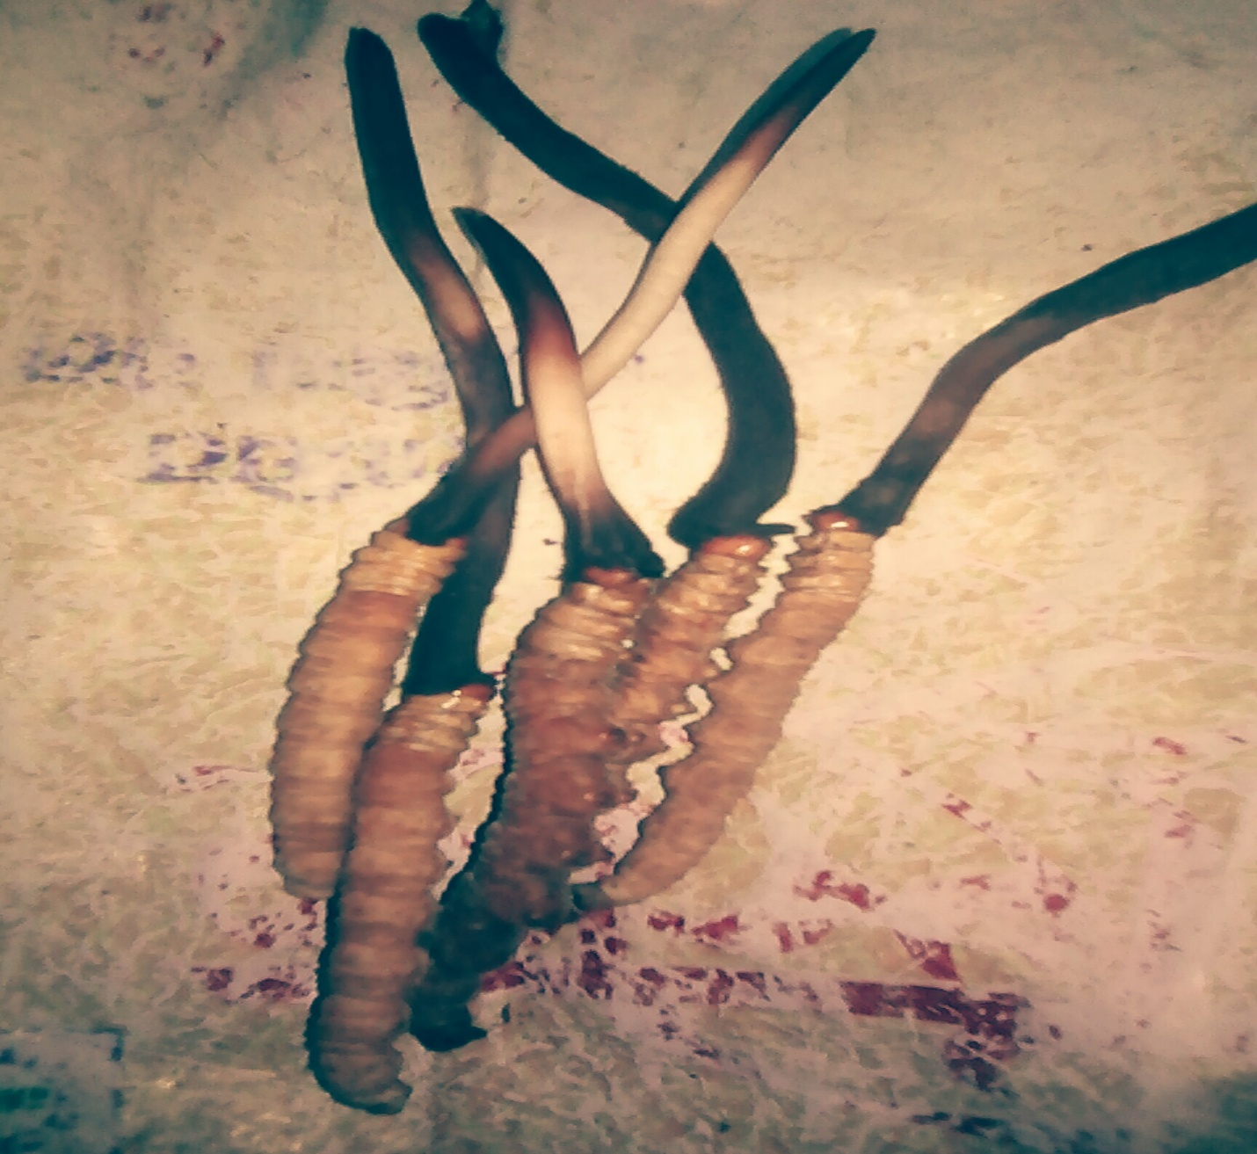

11/09/2015
Budhnailkanta, Chapali 8 kathmandu Nepal
Snow Land Ranag Light of Education School
To
The future village foundation
Subject: Thank you

It’s a great honor to have a great sponsor like you. Your kind support made me able to meet my parents and relative. You have invested on our flight and way expense such as fooding, lodge, potters etc. So, I am very much thankful toward you. Specially Mr. Peter hippo. Once again thank you very much.

With best regard from
Your sincere students
Nima Gurung

